Power BI

**Introduction to Power BI**

Power BI is a business analytics tool developed by Microsoft that enables users to visualize data, share insights, and create interactive dashboards. It connects to a wide range of data sources and transforms raw data into meaningful insights through interactive visualizations and reports.

**Installation Process**

Follow these steps to install Power BI Desktop on your system:

**Step 1: Download Power BI Desktop**

1. Go to the [official Power BI website](https://powerbi.microsoft.com/).
2. Navigate to the "Products" section and select "Power BI Desktop."
3. Click the "Download" button to start downloading the installer.

**Step 2: Install Power BI Desktop**

1. Once the installer is downloaded, double-click on the file to start the installation process.
2. Follow the on-screen instructions:
   * Accept the license agreement.
   * Choose the installation folder.
3. Click "Install" and wait for the process to complete.

**Step 3: Launch Power BI Desktop**

1. After installation, open Power BI Desktop from your start menu or desktop shortcut.
2. Sign in with your Microsoft account to activate the application.

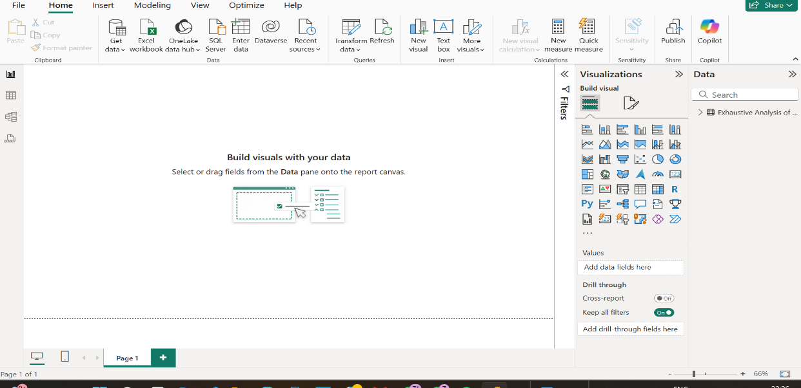

**Power BI Dashboard Overview**

**Key Components of a Dashboard**

1. **Visualizations**: Graphs, charts, and maps that represent data insights.
2. **Tiles**: Individual blocks of content, such as charts or KPIs.
3. **Reports**: A collection of visualizations based on a dataset.
4. **Datasets**: The source data used for visualizations.

**Creating a Dashboard**

1. Import a dataset by clicking on "Get Data."

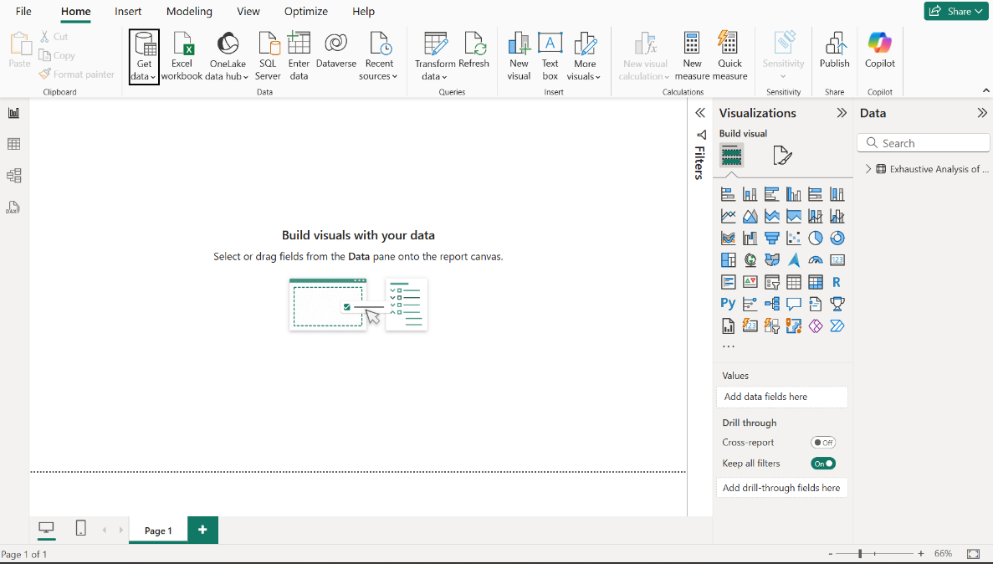

1. Select the data source type (Excel, SQL Server, etc.) and connect.

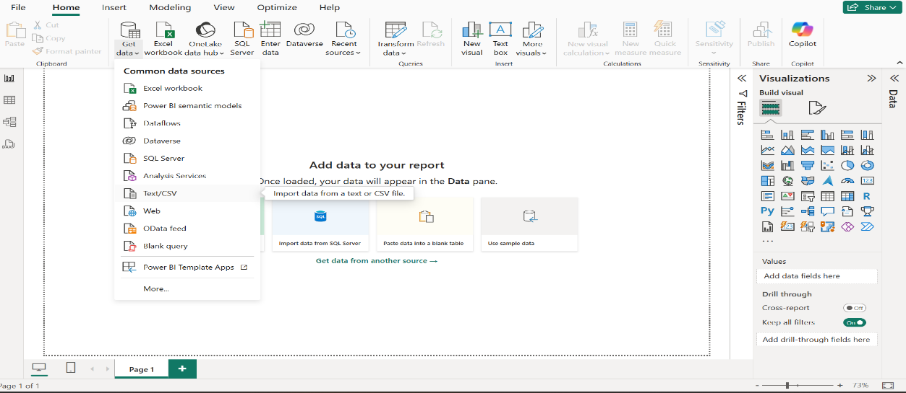

1. After the insert CSV file from device.It’s looks like given images

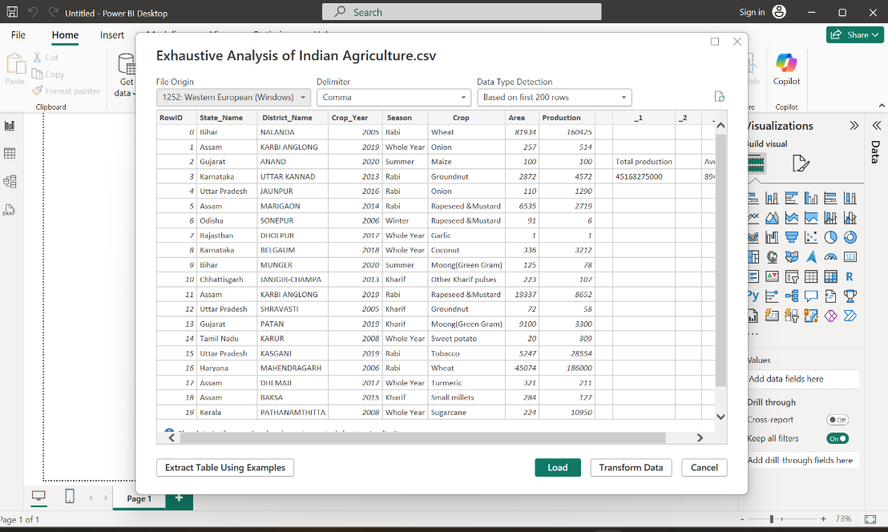

1. Drag and drop fields onto the canvas to create visualizations.
2. Arrange and format the visualizations to design your dashboard.

**ETL Process in Power BI**

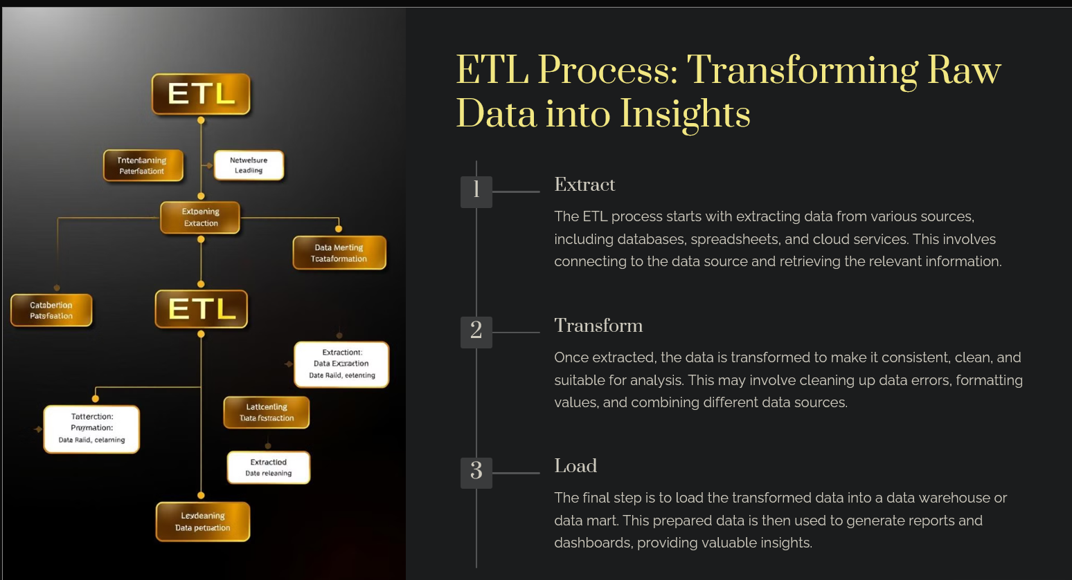

The ETL (Extract, Transform, Load) process in Power BI is carried out using Power Query. Here are the steps:

**Step 1: Extract Data**

1. Open Power BI Desktop and click on "Get Data."



1. Select your data source (e.g., Excel, SQL Server, Web) and connect.



1. Load the raw data into Power Query.

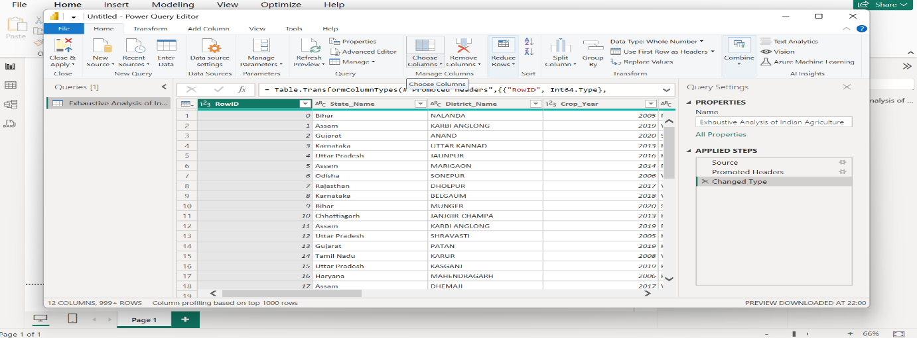

**Step 2: Transform Data**

1. Use the Power Query Editor to clean and shape the data:
   * Remove unnecessary columns.
   * Rename columns for clarity.
   * Replace null values or errors.
   * Apply filters to include relevant data.

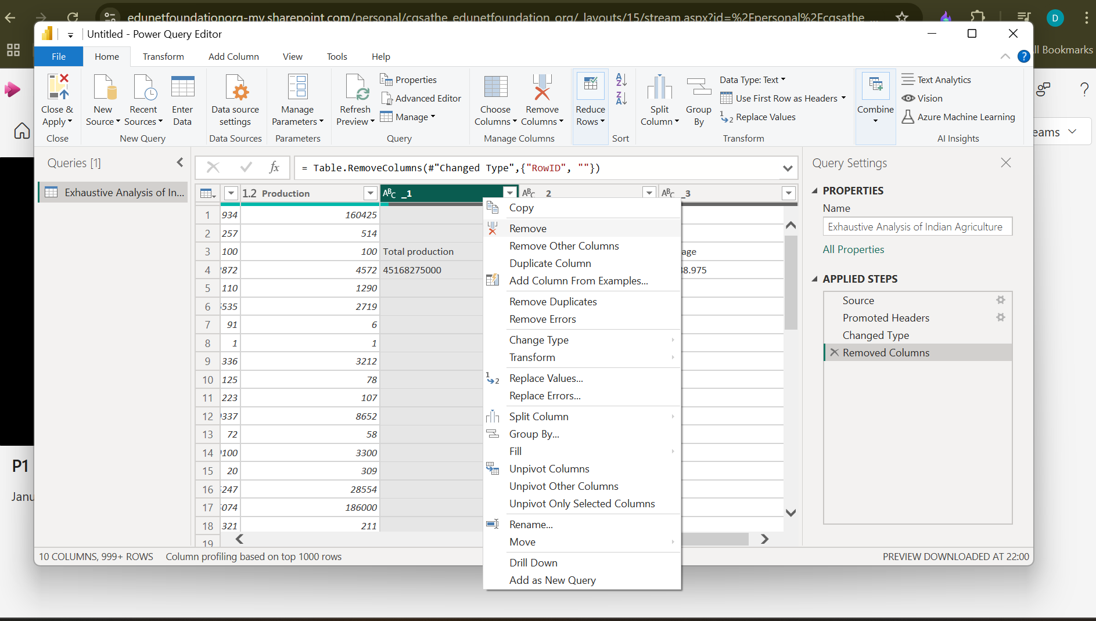

1. Perform advanced transformations such as merging or appending tables.

**Step 3: Load Data**

1. After transforming the data, click "Close & Apply."

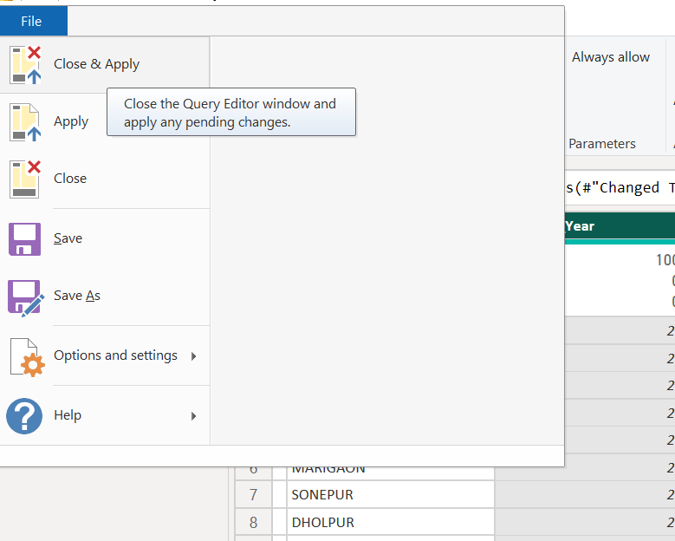

1. The transformed data is loaded into Power BI Desktop for visualization.

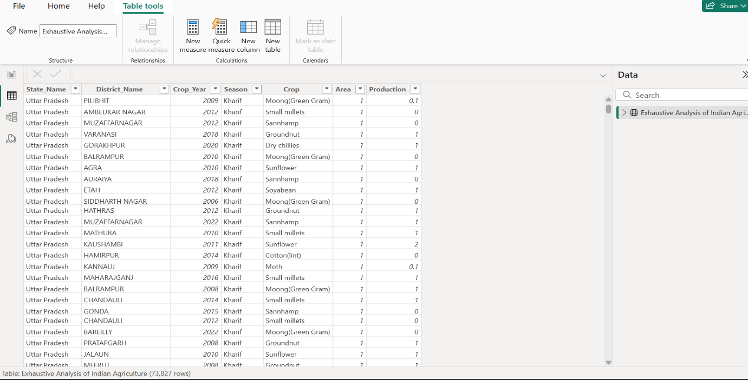

**View Table**

The **View Table** feature in Power BI allows users to visualize and interact with the underlying data tables in their data model. This feature is particularly useful for data analysts and report creators who need to understand the structure and content of their data. Here are some key aspects of the View Table:

1. **Data Exploration**: Users can explore the data in a tabular format, making it easier to analyze and understand the relationships between different data points.
2. **Data Transformation**: While the View Table itself is primarily for viewing, it can be linked with Power Query for data transformation tasks. Users can make adjustments to the data model, such as filtering, sorting, and aggregating data.
3. **Column Insights**: The View Table provides insights into individual columns, including data types, unique values, and null counts, which can help in assessing data quality.
4. **Relationships**: Users can view and manage relationships between tables directly from the View Table, allowing for a better understanding of how data is interconnected.
5. **DAX Integration**: Users can create calculated columns and measures using DAX (Data Analysis Expressions) directly from the View Table, enhancing the analytical capabilities of the data model.

**Review Sidebar**

The **Review Sidebar** in Power BI is a contextual panel that provides additional information and tools related to the current report or data model. It enhances the user experience by offering quick access to various functionalities. Here are some features of the Review Sidebar:

1. **Visualizations**: The Review Sidebar allows users to quickly add and modify visualizations. Users can drag and drop fields from the data model into the visualizations, making it easier to create reports.
2. **Filters and Slicers**: Users can apply filters and slicers directly from the Review Sidebar, enabling dynamic data exploration and analysis. This feature allows for a more interactive experience when viewing reports.
3. **Formatting Options**: The Review Sidebar provides formatting options for selected visuals, allowing users to customize the appearance of their reports without navigating away from the current view.
4. **Bookmarks and Selections**: Users can manage bookmarks and selection states from the Review Sidebar, which is useful for creating guided analytics and storytelling within reports.
5. **Collaboration Tools**: The Review Sidebar may also include collaboration features, such as comments and sharing options, enabling teams to work together more effectively on reports and dashboards.